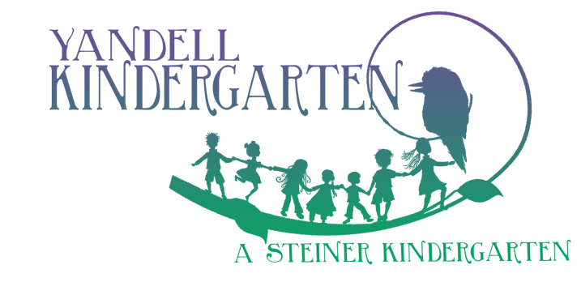
Yandell Kindergarten
Nurturing Imagination and Wonder in Every Child
www.yandellkinder.com.au
T: 9435 9472
Community Drive, Greensborough VIC 3088
ABN: 4486 587 9482

Silent Auction Donation Form
Business: Click here to enter text. Name: Click here to enter text.
Phone: Click here to enter text. Email: Click here to enter text.
Address: Click here to enter text.

Description: Please provide the details you think would be ideal for bidders to read about your item. Click here to enter text.

Services: If your donation is a service please provide details, including expiry date, so the winning bidder can claim their purchase. Click here to enter text.

Object: If your donation is an object, will it be available for viewing and pick up on the day? (If so, please provide details of size). If not, please provide collection details. Click here to enter text.

Value: What is your estimation of the retail price of the item/service? Click here to enter text.

Are there any other considerations you think we should know about in relation to your donation? Click here to enter text.

Yandell Kindergarten is grateful for your contribution to our Silent Auction
As part of our expression of gratitude we are offering the opportunity for you to advertise your business at the Kinder in the lead up to the event. If you have any business cards, flyers, etc., please forward them to us at the address below with your completed form.
PLEASE RETURN THIS FORM BY 13 APRIL 2015 to olivia.wykes@hotmail.com or post Attn: Olivia Wykes, Yandell Kindergarten, Community Drive, Greensborough 3088

