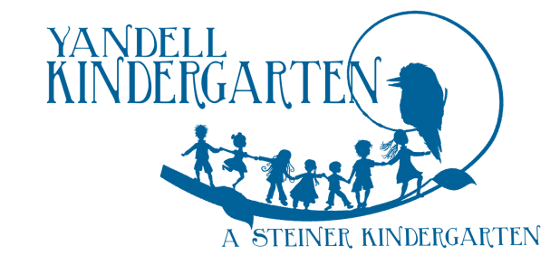

Registration of Interest – 3YO Ring-a-Rosie
Thank you for your interest in Yandell Kindergarten’s three-year-old Ring-a-Rosie Program. You may register your child for Ring-a-Rosie in the year that your child turns two. Children are eligible for attendance in the three-year-old kindergarten program provided they have turned three before 30 April of the year that they are to attend the three-year-old kindergarten program. To have an enrolment confirmed at Yandell Kindergarten, parents/carers have to provide the service with:
- a current Immunisation History Statement from the Australian Immunisation Register; AND
- the statement must show that the child is up to date with all vaccinations that are due for their age, or that they are able to receive.

Please be aware that Banyule City Council manages all four-year-old kindergarten enrolments. We strongly advise you to place your child on the Council list early to avoid disappointment. Four-year-old kindergarten application forms are available from:
- Banyule City Council service centres
- Banyule City Council website: (http://www.banyule.vic.gov.au/Services/Health-and-Community-Services/Children/KindergartensPreschools/4-Year-Old-KindergartenPreschool-Enrolment).

Enrolment Fee
A non-refundable enrolment fee of $20 is payable when you submit this form. Your child will be placed on our waiting list in the order we receive your form and fee.
The following payments are accepted: cash and electronic funds transfer (EFT). Payment details appear below:
EFT Details  Bendigo Bank  Account name: Yandell Kindergarten Inc.  BSB: 633000  Account number: 151703279  Reference: Child’s first name, group and year of interest (e.g. Sasha3YO2021) | Cash payments can be made directly to:  - Carolyn Camm (Administration Manager)  - Teachers  You will receive a receipt for cash payments.

Offers
First round offers are made during July/August in the year before your child begins kindergarten.

Form Submission and Enquiries
Please return your completed form to Yandell Kindergarten, Community Drive, Greensborough VIC 3088 or email to adminmanager@yandellkinder.com.au. Enquiries may be made by calling the kindergarten on 9435 9472 or emailing adminmanager@yandellkinder.com.au.

Office use only
Date form received: by:
Payment: Cash/EFT
Payment Receipt No.:

Registration of Interest – 3YO Ring-a-Rosie

Child’s Information
Child’s First Name: | Child’s Surname:
Date of Birth: | Sex: Male Female
Applying for a 3YO place in year: 20.........

Family Information [Please notify us of any changes]
Primary Parent/ Guardian: | Name:
Address:
Postcode:
 | Mobile: | Home Phone:
 | Email:
Other Parent/ Guardian: | Name:
Address:
Postcode:
 | Mobile: | Home Phone:
 | Email:
I/we wish to express my/our interest in applying for a place at Yandell Kindergarten’s three-year-old Ring-a-Rosie program. Please add my child to your wait list.
Signed: ________________________________________________________ Date: ___________

